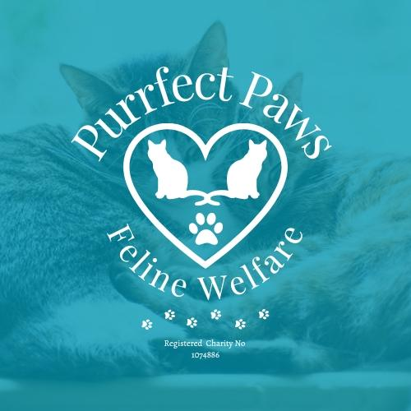
KIDNEY / RENAL DISEASE
Kidneys filter waste products out of the blood to form urine.
Having disease of the kidneys is one of the most common illnesses affecting middle-aged and older cats. Unfortunately, damage to the kidneys is irreversible and deteriorate over a period of time. However, with the help of treatments, affected cats can often maintain a good quality of life for several months or years.
Chronic kidney disease
This is the most common type and refers to a gradual-onset, long-term disease of the kidneys. The damage caused is usually due to the natural ageing process and is often seen in cats over seven years of age.
Inherited defects – especially in certain breeds of pedigree cats, can also be cause of chronic kidney disease.

Acute kidney disease
Is a sudden damage to the kidney(s) and is usually as a result of trauma, poisoning, infections or blockages caused by lower urinary tract disease. Signs can be sudden and unless urgent treatment is given, it can rapidly become fatal. If treatment is received in time, a cat with acute kidney disease may then go on to suffer from chronic kidney disease.

Kidneys not working properly
This can have a number of effects on the cat, such as:
a build-up of waste toxins which can damage other body tissues
high blood pressure
loss of essential minerals & excess fluid in urine
anaemia

Signs of Kidney disease
Most common are:
increased thirst  passing more urine  poor appetite  weight loss  poor coat condition  Normally these signs occur once the cats kidneys are 70% or more damaged, as cats are very good at hiding pain etc | vomiting  lethargy  depression  bad breath

Diagnosis
A blood and urine test for high levels of waste products.
Early diagnosis and treatment may significantly extend an affected cat’s life expectancy.

Treatment
This depends on the stage of kidney failure, the signs shown and impact of the condition on other body systems.

Fluid therapy
If your cat becomes very dehydrated, the vet may administer extra fluids to help replace lost salts and water.

Medication

Long-term oral medication to control protein loss in urine and/or control high blood pressure as both will further damage your cat’s kidneys
medication for specific problems associated with kidney disease, such as vomiting
long-acting injections to stimulate appetite and slow weight loss

Diet
A specific diet that can reduce the workload on the cat’s kidneys by decreasing production of waste products in the blood. Dietary management is a most important factor in managing renal disease and to improve quality of life. If possible, restrict the level of phosphate intake, or use a supplement to bind phosphate and restrict its absorption. Encourage fluid intake as this is beneficial too.

Your cat is likely to be prescribed a diet for the rest of their life and probably need medication. Carefully observe your cat for any changes in eating, drinking and urinating. Regular check-ups will be beneficial to monitor progression of the disease.

Depending on the severity of kidney damage, with regular monitoring, correct medication and treatment, many cats with kidney disease can go on to lead long and happy lives. Please note, however, the condition will deteriorate over time.

