Charity Number 1074886

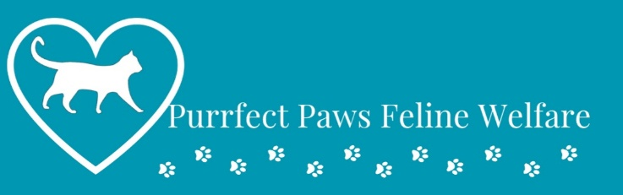
FELINE FEEDING
&
OBESITY INFORMATION
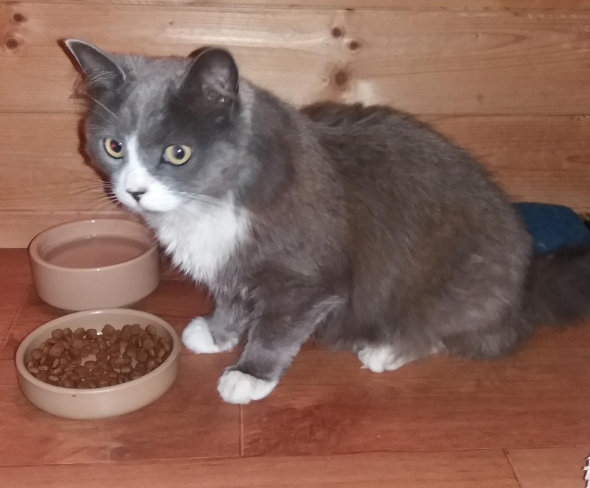

Obesity
It is important to manage a cat’s weight by ensuring they are not overfed and have plenty of opportunities to exercise. If a cat is overweight it normally means the body weight is greater than 15 per cent of their ideal body weight. A cat is termed as obese when they are 30 per cent above their ideal weight.
In obese cats there is often a droop underneath. When a cat is overweight, it can restrict their ability to groom properly and also suffer joint problems and can have an increased risk of developing diseases such as diabetes and urinary infections. In very severe cases, you could actually kill your cat with kindness by overfeeding.
A vet can help you to ensure that the cat will get the right amount of food without being overfed. With overweight cats, it is a good idea to weigh food out daily. Remember that any treats will add calories.
Overweight cats should never be starved or put on a ‘crash diet’ as any period of no food can very quickly be harmful. A gradual, steady decrease in bodyweight is ideal – it may take up to a year for a severely overweight cat to reach its ideal body condition.
It can be difficult to manage in multi-cat households. Feeding the overweight cat in a separate room can give the other cats in the household some time to eat. Any leftover food should ideally be removed before the overweight cat is let out.
Provide the overweight cat with a little exercise, as it is an important part of weight control, indoor cats are particularly prone to obesity and it could be a manifestation of stress.

Ensure your cat has fresh water available at all times:
cats that are fed an entirely dry diet tend to drink more water. Wet food is 90 per cent water so cats require little in addition to this but always offer water.
Some cats prefer to drink from puddles or ponds – this is perfectly normal.
If your cat is noticeably drinking more or less, this may be an early indicator of a medical problem, please contact your vet.
Please avoid giving your cat cow’s milk – most cats are unable to tolerate it as they are lactose intolerant and it can lead to sickness and diarrhoea.
Specially formulated cat & kitten milk is available but should only be given as an occasional treat and never given instead of water.

A balanced diet
Cats need a balanced diet with the right amount of nutrients, so it’s best to stick to a reputable pet food which includes everything cats need to stay fit and healthy.

Commercial pet food is classified as either complete or complementary:
complete foods provide all the necessary nutrients in the right balance so that no other food needs to be added
complementary foods must be combined with other foods to provide a complete balance of nutrients
whatever you choose, cats always need fresh water and this should be changed daily
Cats have a higher protein requirement but there is no need to feed them homemade or fresh food, unless recommended by a vet for medical reasons.
If you have recently adopted a cat, initially it’s best to keep them on the same food as a sudden change can cause upset stomach. If you do change your cat’s diet, try to slowly introduce any new food by mixing it with the old food over a period of a week plus.

Remember, a cat is a carnivore and must have amino acids such as taurine that can only be found in meat, so they cannot be a vegetarian

To eat wet or dry food?
You can feed your cat wet or dry food, or a mixture of both.

Wet foods
Normally available in tins or pouches. Wet food is soft and there are many different flavours to choose from. You may find it more appealing to a fussy eater.

Dry foods
These can be a practical choice for many owners as they can be left out all day for your cat to nibble on and can be beneficial for the teeth and gums. If your cat has a medical condition requiring increased water intake, such as urinary problems, it may be best to avoid dry food and feed only wet food. Guide: Cats and the law.
How often?
Fresh wet food should be replaced at least twice daily and dry food at least once daily. Once cats are neutered, they normally have reduced energy needs, so consider cutting down the daily amount of food accordingly.

To encourage cats to drink more:
ideally use glass, ceramic or metal bowls. Plastic can taint the water
offer a large, shallow water bowl with a large surface area. Some cats don’t like their whiskers touching the sides of the bowl
try offering a water fountain – cats often prefer moving water
Provide more than one bowl in different locations throughout the house

Why isn’t my cat eating?
Some cats can be fussier than others, cats may stop eating because of stress or illness and should be checked by a vet. Odour, texture and temperature of food are important and can be manipulated to tempt the problem feeder or sick cat. To encourage a cat to eat, try:
offering a range of different wet and dry foods at different times – making sure you introduce new foods slowly
giving wet food at room temperature
offer regular small amounts rather than a large bowl.
offer food with a strong odour.
sitting with your cat or hand feeding can encourage eating to start.
a sick cat may need to be given a special diet by a vet who can advise on how best to tempt the cat
Food containing onions, or onion powder, can be potentially toxic and life threatening if ingested by a cat.

Special diets and life-stage feeding
Cats’ dietary needs change according to their age and health and there are a range of specific foods available eg kitten, senior, indoor, sensitive or low calorie. A special diet may be prescribed by your vet if your cat has a health problem such as kidney disease or joint problems. This should be given as instructed, only to the cat it is prescribed to. If possible, it is preferable to introduce the new diet gradually while the cat still has access to its original diet.
It can be difficult to feed a prescription diet to a cat if you have other cats in the household. See the above information on obesity for some tips on how to feed cats different diets.

Pregnant cats and mums feeding kittens
Pregnant cats and those feeding kittens have increased nutritional requirements and need the same high-protein kitten food as weaned kittens. Give the pregnant cat unlimited access to kitten food and fresh drinking water. During pregnancy she is likely to eat only a little more than normal but when she is suckling kittens, she has to produce so much milk that she may eat double or triple her normal amount.

Kittens
You can begin the weaning process by providing well-mashed kitten food from three to four weeks of age. If the litter is very large you may have to supplement their diet with specialised kitten milk at an earlier age. If the mum cannot feed her young or the kittens are orphaned, you will need to take over the feeding completely or ask a vet or cat rescue to help. Kittens have small stomachs and high energy requirements, so need to be fed little and often. Their food should generally be checked and replaced four times daily.

about your cat on

